Time: 60 minutes
Directions: Each of the 30 multiple-choice questions is followed by five possible answer choices. Choices A through D will provide answers, while Choice E is for none of the above. Scoring will be as follows: 5 points for a correct answer, 0 for a wrong answer, and 1 for a blank answer (for a maximum possible score of 150). Figures are not necessarily drawn to scale. Do not choose incomplete answers: if a question has more than one solution, do not select a choice that only provides one of the solutions!
Calculators are not permitted.

- +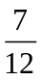 =
A) 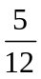 B) C) 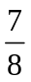 D)  E) NOTA

- 4³ =
A) 7 B) 12 C) 64 D) 108 E) NOTA

- Superman only fights 15% of his 20 major villains twice. How many villains does Superman fight twice?
A) 3 B) 4 C) 5 D) 6 E) NOTA

- Which represents the following: five hundred ninety-six thousandths?
A) 0.0596 B) 0.596 C) 0.695 D) 596,000 E)NOTA

- If Braniac claims to only use of his brain, what percent of his brain does he use?
A) 25% B) 30% C) 75% D) 80% E) NOTA

- Chasing Prankster, Superman flew around a square city block. Each of the four streets he flew down was 0.6 miles long. If Superman only flew in one complete square, how far did he fly?
A) 1.2 miles B) 2.4 miles C) 6 miles D) 12 miles E) NOTA

- Express 29.7% as a decimal.
A)0.0297 B) 0.297 C) 2.97 D) 29.7 E) NOTA

- What is the prime factorization of 240?
A)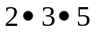 B) 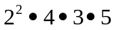 C)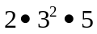 D)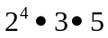 E) NOTA

- Which number of ounces of Kryptonite would be most harmful to Superman?
A)10.043 B) 10.430 C) 10.304 D) 10.4 E) NOTA

- 6.002 + 5.03 =
A)6.503 B) 6.505 C) 11.032 D) 11.05 E) NOTA

- 15 + (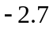) =
A)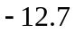 B) 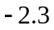 C) 12.7 D) 17.7 E) NOTA

- 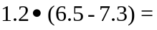
A)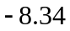 B)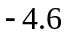 C)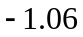 D)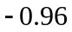 E)NOTA

- Bizarro has k pieces of kryptonite to use against Superman. However, he needs twice as much plus an additional 6 pieces to defeat him. Which expression represents the correct amount needed to defeat Superman?
A)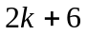 B)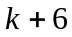 C)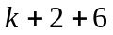 D) 6 E) NOTA

- What is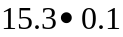?
A)0.153 B) 1.53 C) 15.3 D) 15.4 E NOTA

- 7+x = 16. Solve for x.
A)1 B) 7 C) 9 D) 23 E) NOTA

- 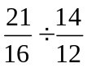
A)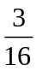 B) C) D) E) NOTA

- While working on a story for the Daily Planet, Clark Kent found he had reported a number as 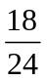. What is this fraction in lowest terms?
A) B)  C) D) 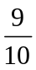 E) NOTA

- The “S” Superman logo only takes up 40% of Superman’s chest. If his chest is 200 in², how much of this area is taken up by his logo?
A)40 in² B) 80 in² C) 100 in² D) 140 in² E) NOTA

- Clark Kent has to write of a page plus another 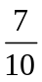 of a page for one of his articles. Assuming every page is the same size, what is the total amount he has to write (in fractions of a page)?
A)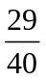 B) C) D)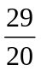 E) NOTA

The following is for questions 20 and 21:
In one night, Mr. Kent slept for of a night.

- What percent of the night did he sleep?
A)60% B) 70% C) 75% D) 90% E) NOTA

- If one night has 8 hours in it, how many hours did he sleep?
A)4.8 B) 5 C) 6.4 D) 8 E) NOTA

- 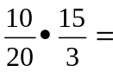
A) B) C) D)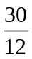 E) NOTA

- Express 0.625 as a fraction in lowest terms.
A)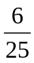 B) C) D)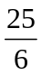 E) NOTA

- Which number is out of order in the number line?
A B C D

0.006 0.07 0.008 0.09 0.1 0.101 0.11

E) NOTA

- Express 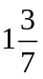 as an improper fraction.
A)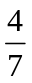 B) 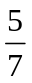 C)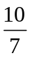 D)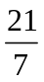 E) NOTA

- 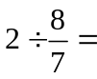
A) B) C) D)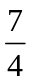 E) NOTA

- 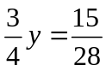. Solve for y.
A) B) C) D)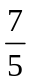 E) NOTA

- Express as a mixed number.
A)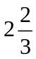 B)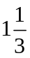 C)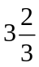 D)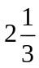 E) NOTA

- One night, Superman battled Lex Luther for 3.4 hours. What is this in hours and minutes?
A) 2 hours, 4 minutes B) 3 hours, 4 minutes C) 3 hours, 24 minutes
D) 4 hours, 24 minutes E) NOTA

- Superman must fly to the top of a triangular-shaped building. He knows that the area of the front face is 12 units and the length of the base to be 6 units. How tall is the building?
A)2 units B) 4 units C) 6 units D) 12 units E) NOTA

CHILES MINI MU COMPETITION
PREALGEBRA – SUPERMAN : REVENGE OF THE RATIONAL NUMBERS
ANSWERS

1) D
2) C
3) A
4) B
5) C
6) B
7) B
8) D
9) B
10) C
11) E
12) D
13) A
14) B
15) C

16) D
17) C
18) B
19) D
20) A
21) A
22) C or D
23) B
24) B
25) C
26) D
27) E
28) A
29) C
30) B

SOLUTIONS

- D 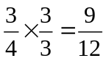, 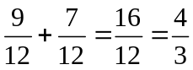
- C 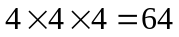
- A 15% of 20 => 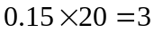
- B Thousandths means it’s a decimal and fills three places after the decimal point. 0.596.
- C 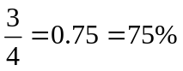
- B 0.6(4)=2.4 miles
- B 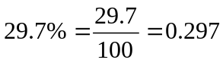
- D
- B 10.430 is the greatest out of all of them
- C 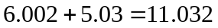
- E 15 – 2.7 = 12.3
- D 6.5-7.3= -0.8, 1.2(-.8)=-0.96
- A Twice of k plus 6 = 2k+6
- B 15.3(0.1)=1.53
- C Subtract 7 from each side. 16-7=9, x=9
- D 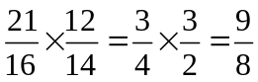
- C 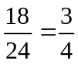
- B 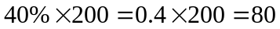in²
- D 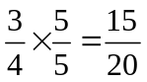, 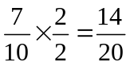, 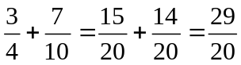
- A =0.6=60%
- A x8=4.8
- C 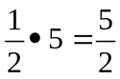
- B 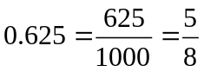
- B 0.008 is less than 0.07 and should be placed to the left of it.
- C 1x7=7, 7+3=10, numerator =10, denominator =7 =>
- D 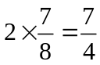
- E Multiply each side by , 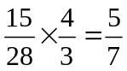, y=

- A 3 goes into 8 twice with a remainder of 2, therefore 2 is the whole number and the fraction is  =>
- C 0.4(60)=24 minutes, 3 hours, 24 minutes
- B A=0.5bh, 12=0.5(6)h, 12=3h, h=4

